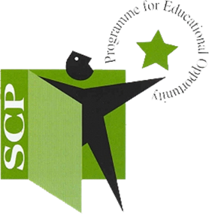
Tipperary Town & District School Completion Programme
The Tipperary Town & District school completion programme (SCP) is a targeted programme of support for children in both primary and post primary school to students that have been identified as potentially at risk of early school leaving or are transitioning to alternative learning courses and help improve school attendance. We currently work with four local primary schools and one post primary school in the Tipperary Town area. Our Scp programme aims to provide support to students in a variety of different ways both in and after the school day. Our hope is that both students and families alike will engage in the supports that we offer and that we are on hand to make school going that much easier and less stressful.
Our team is made up of
Co-ordinator Helen Kennedy helen.kennedy@scp.ie
Project worker Chanice Quinn Chanice.quinn@scp.ie
Project Worker Stephanie Walsh Stephanie.walsh@scp.ie
Project Worker Alanna o’ Donovan Alanna.odonovan@scp.ie

We offer support programmes which range from whole class engagement/ small groups / one to one work. These programmes work on areas and teach skills such as improving social & emotional literacy & expression, develop their ability to communicate appropriately, effective strategies to cope and manage conflict, problem solving skills, learning empathy skills and improve general wellbeing, social & emotional management.
Friends For Life Working Things Out
Roots Of Empathy Rainbows Programme
Youth Identity Programme Stop Think Do
Mind Up Programme Weaving Wellbeing
Mentoring For Achievement Programme (MAP) Coding Club
Transition Programme From Primary To Secondary School

We engage students in lunchtime and afterschool sports clubs.

We also offer both Primary and secondary school homework clubs which will provide a supportive and structured routing to complete homework. This will also include the opportunity to go on Easter and summer camps with us.

We can be contacted through our emails above and also on Facebook & Instagram and have also included a helpful link to our padlet which is full of great supports, activities and helpful websites
https://www.facebook.com/Tipperary-Town-District-School-Completion-Programme-208345913125421/
https://instagram.com/tipperarytownscp?igshid=1l1asz3zmxg3s
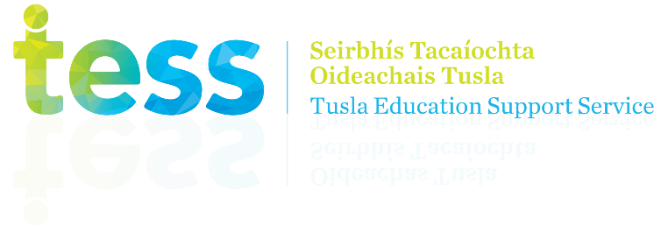
https://padlet.com/stephaniewalsh/4fun6s29xg3l

