TY Scrapbook Challenge
- Read a book and write about it!

- The book I last read maybe 3 months ago, which was quite awhile a go but I have since got back into reading, was the iconic ‘To Kill a Mockingbird’ by Harper Lee. The book was highly intriguing and mainly dealt with the theme of prejudice in the racist 1930s. To summarise the plot quickly, a black man is accused of raping a woman in the local town of Maycomb, and a lawyer called Atticus Finch is to defend him of the charges in court. The events of the book are all through the eyes of young ‘Scout’ Finch, Atticus’ daughter, as she recalls the mischief her and her brother Jem Finch got up to with their friends, the neighbours she had, and of course the trial. The book is so innocent in the sense that it is through the eyes of a 9 year old girl; her and her brother can’t grasp as to why Mr Robinson, the man accused of raping the woman, is badly treated because of the colour of his skin.
- The plot
Scout Finch lives with her brother, Jem, and their widowed father, Atticus, in the sleepy Alabama town of Maycomb. Maycomb is suffering through the Great Depression, but Atticus is a prominent lawyer and the Finch family is reasonably well off in comparison to the rest of society. One summer, Jem and Scout befriend a boy named Dill, who has come to live in their neighborhood for the summer, and the trio acts out stories together. Eventually, Dill becomes fascinated with the spooky house on their street called the Radley Place. The house is owned by Mr. Nathan Radley, whose brother, Arthur (nicknamed Boo), has lived there for years without venturing outside.

Scout goes to school for the first time that fall and detests it. She and Jem find gifts apparently left for them in a knothole of a tree on the Radley property. Dill returns the following summer, and he, Scout, and Jem begin to act out the story of Boo Radley. Atticus puts a stop to their antics, urging the children to try to see life from another person’s perspective before making judgments. But, on Dill’s last night in Maycomb for the summer, the three sneak onto the Radley property, where Nathan Radley shoots at them. Jem loses his pants in the ensuing escape. When he returns for them, he finds them mended and hung over the fence. The next winter, Jem and Scout find more presents in the tree, presumably left by the mysterious Boo. Nathan Radley eventually plugs the knothole with cement. Shortly thereafter, a fire breaks out in another neighbor’s house, and during the fire someone slips a blanket on Scout’s shoulders as she watches the blaze. Convinced that Boo did it, Jem tells Atticus about the mended pants and the presents.
To the shock of Maycomb’s racist white community, Atticus agrees to defend a black man named Tom Robinson, who has been accused of raping a white woman. Because of Atticus’s decision, Jem and Scout are subjected to abuse from other children, even when they celebrate Christmas at the family compound on Finch’s Landing. Calpurnia, the Finches’ black cook, takes them to the local black church, where the warm and close-knit community largely embraces the children.

Atticus’s sister, Alexandra, comes to live with the Finches the next summer. Dill, who is supposed to live with his “new father” in another town, runs away and comes to Maycomb. Tom Robinson’s trial begins, and when the accused man is placed in the local jail, a mob gathers to lynch him. Atticus faces the mob down the night before the trial. Jem and Scout, who have sneaked out of the house, soon join him. Scout recognizes one of the men, and her polite questioning about his son shames him into dispersing the mob.
At the trial itself, the children sit in the “colored balcony” with the town’s black citizens. Atticus provides clear evidence that the accusers, Mayella Ewell and her father, Bob, are lying: in fact, Mayella propositioned Tom Robinson, was caught by her father, and then accused Tom of rape to cover her shame and guilt. Atticus provides impressive evidence that the marks on Mayella’s face are from wounds that her father inflicted; upon discovering her with Tom, he called her a whore and beat her. Yet, despite the significant evidence pointing to Tom’s innocence, the all-white jury convicts him. The innocent Tom later tries to escape from prison and is shot to death. In the aftermath of the trial, Jem’s faith in justice is badly shaken, and he lapses into despondency and doubt.

Despite the verdict, Bob Ewell feels that Atticus and the judge have made a fool out of him, and he vows revenge. He menaces Tom Robinson’s widow, tries to break into the judge’s house, and finally attacks Jem and Scout as they walk home from a Halloween party. Boo Radley intervenes, however, saving the children and stabbing Ewell fatally during the struggle. Boo carries the wounded Jem back to Atticus’s house, where the sheriff, in order to protect Boo, insists that Ewell tripped over a tree root and fell on his own knife. After sitting with Scout for a while, Boo disappears once more into the Radley house.
Later, Scout feels as though she can finally imagine what life is like for Boo. He has become a human being to her at last. With this realization, Scout embraces her father’s advice to practice sympathy and understanding and demonstrates that her experiences with hatred and prejudice will not sully her faith in human goodness.

﷟What I loved about the book
- I think that was one of the things so beautiful about the book; how in the eyes of a child, so innocent and pure; things are often seen as more true as Scout sees past the blindness of the adults in the neighbourhood. She poses the question ‘why should he be treated different? He can do anything we can, his skin is just a different colour.’ It also showcases how loving and wise her father, Atticus raised her. She is not prejudiced like any of her older neighbours, she is not mean in her nature or judgemental based on skin colour or physical appearance, she is as wise as the neighbourhood and the most innocent alongside her brother. It shows the importance of a good parent, and as well as the influence a parent can have on the child; as well as the sheer innocence as child’s point of view contains in comparison to the view of most of the adults; full of prejudice and hate, they were mostly hating Tom Robinson for the sake of hating, for the colour of his skin, while Jem, Scout’s slightly older brother, cried after the trial, showing he saw Mr Robinson as human and couldn’t understand why he was deemed guilty after Atticus proved the prosecutor’s witnesses as flawed and showed they lied under oath. The book is by far the best I’ve read that can showcase a message so clear and so strong and is probably one of my favourite books of all time for that reason alone.
- The plot itself, especially when it came to the trial, was breath taking at times, and it was one of the first and probably will be the last book that made me read it in utter suspense. After Atticus put up a damning case as to why Mr. Robinson was clearly not guilty, Mr. Robinson was still guilty in the eyes of the jury. This, to the reader at the time, may seem like a huge loss, however, then Atticus makes the point that ‘It took the Jury six hours to deem a black man guilty, instead of 20 minutes. We won, not in the way we wanted, but we proved there is hope.’ (That isn’t the exact quote, but was similar from my memory) I love how the book makes you consistently realize how times have changed so much, and how awful it must have been to live in such a time of prejudice, but at the same time there was hope, and that hope and people like Atticus and his family carved out the far more equal society we have today, and though it isn’t perfect, moments like the trial which seem like losses, can sometimes be the start of a new found inspiration for good and kindness, as well as justice.
- I honestly can say there was nothing I disliked about the book. I did find that if you read the blurb and you know the trial is coming at some part of the book, it could be boring at times to read about Scout’s summer as oppose to whatever chapter the trial was going to start in, but the author with her use of powerful imagery is able to draw you in to even the most simplest scenes such as the children playing in the garden or making a snowman, so you are always kept in the Scout’s world, but at the same time I do have to say, the trial is probably the best chapter of a book I have ever read; the way Atticus acts in the court room is just brave and admirable, all while the witnesses with their claims on Mr Robinson make the atmosphere so intense often by using racist remarks or exaggerated claims, but Atticus leaves them all stooped by calling up his only witness, Mr Robinson himself, and then making the crowd in the courthouse shook with how he cross analyses the witnesses on the prosecution side and leaves them dumbfounded. Just an amazing part of an all around amazing book.
Thoughts on the characters:
Scout Finch: As said above she is so innocent in her ways, but she is also a very tough girl, often called a tomboy in school. She is very intelligent for her age and is a prime example, especially at the end of the book, at to what any parent should hope their child develops to be; kind, non- judgemental and non-prejudiced.

Jem Finch: Extremely similar to Scout but is often a mentor to scout, showcasing his intelligence and is also very brave, often protecting his sister from the world, especially near the end where she tries to fight the attacker, Bob Ewell.
Atticus Finch: A role model in my eyes and an all around inspiration. The cleverest and most intelligent character in the book, as well as the most respectful. Atticus is ahead of his time in the sense that he sees past issues of skin colour and prejudice, and reminds his children often not to judge a book by it’s cover. Despite the long respected position he built as a lawyer for the town, he is gladly willing to put that at risk if it means to defend a man he knows is innocent, he is a just, brave and determined lawyer and person, and showcases the importance of standing up for what is right and teaching others to do the same. When I think of law and justice, as well as bravery as a whole, he always comes to mind. He is my favourite character in the book.

Boo Radley: Boo is a caring, loving soul, and despite all the rumours in the town and all the opinions the townsfolk and the children, Scout and Jem in particular have about him, in the end he saves the lives of Scout and Jem showing that you should never judge a book by it’s cover. What started out as what could only be pictured as a creepy man that never leaves his house, can only be described as a hero in the end.
Bob Ewell: Ewell and his family are probably one of the most hated characters in a book ever. Period. Ewell is a drunk, spending all his family’s money on drink and is an extreme racist, harassing Mr. Robinson’s wife after the trial. He is hateful and bitter, and as said the fact he tried to stab Atticus’ children near the end of the book shows how evil and wicked he was. He got what was coming to him; both when Atticus ruined his family name in the trial by making everyone come to the realization Ewell lied on the stand, and when Boo killed Ewell to save Scout and Jem. He was an example of everything wrong with living back then.
Would I recommend this book?
I would absolutely recommend this masterpiece. The book provides readers with an insight into the past and will prove to educate the reader indefinitely on living in the 1930s. The plot is quite an intense one and when it develops and key scenes emerge, they keep you on the edge of your seat, and it teaches some vital life lessons. The book goes into extreme detail on characters and settings, so to avid readers out there, I would highly recommend. The book is quite long and numbers 300 pages and uses highly descriptive language and vocabulary, so I wouldn’t recommend to newer or rare readers at all. The book would suit anyone over the age of 14.

Find on the following page my letter to thank the health workers at Tipperary Town Primary Care Centre for the essential and amazing work during the Covid 19 Pandemic.

- Give back to the community: Letter to healthcare workers.

Rory Sampson
Rathdermot,
Bansha,
Co. Tipperary

04/05/2020

Tipperary Primary Care Centre,
Rosanna Road,
Tipperary town,
Co. Tipperary.

Dear All staff members of Tipperary Care centre,
As part of a Transition Year scrapbook project me and fellow St. Ailbes students are working on, one of the challenges was to give back to the community, so I wanted to write the following letter to address the amazing work you are all doing during these hard times.
The work you are doing is ever so inspiring; it was always inspiring to me but during this crisis, I and many people I’m sure you’ve noticed have gained a newfound respect and thankfulness for the work you do. The work you do, to call it brave, would be an understatement, as it is nothing short of heroic. You are no longer staff members, doctors, or nurses in light of this pandemic, but you are all heroes and it should not go without acknowledgement.
The inspiration you all serve to be to those of us who are watching from the sideline, cannot be put into words, and I hope one day I will have such courage and will be able to make such a difference in people’s lives as you are currently doing at the frontlines. I hope when this pandemic finally comes to an end – no doubt as a result of your incredible work and bravery, that the work you did and shall continue to do will not just be acknowledged by me, but by the world for decades to come.
From the bottom of my heart, I cannot express how thankful I am for the sacrifices you make everyday, especially during these hard times. Your dedication and commitment is saving countless lives, and making countless differences too.
From a young person who you’ve inspired greatly,
Thank you.
Rory Sampson.

- High, Low, Kudos of TY.

Highs:
- I think one of the best highs of TY was the freedom. Classes were easy going, no study nor homework after school and plenty of opportunities to get out of the classroom. This allowed me and many others to develop socially and I found myself getting closer to people I may have rarely spoken to before TY. I got closer to my friends as I could connect and talk to them more after school because of little to no school work, and opportunities such as Ballyhass and days out really allowed us to bond and have a good time together, and I think that was just an overall general high everyone got out of TY.
- Another High was the opportunities to learn in a more relaxed and engaging experience as oppose to the classroom; a more hands on practical approach to things was definitely noted by myself in TY.
A prime example of this was the enterprise module. Me and my friends were immediately interested in that as we always admired the previous TYs efforts, so of course we entered it. With the help of student teacher Mr Czerniak; who may I add was also a highlight of TY, me and my friends just got along great with him and was arguably one of our most engaging and helpful teachers during all of TY, we picked up so much about running our Tiny business and we really became engaged in the two enterprise competitions. It was extremely satisfying when we found out we won best display in the Student Enterprise Competition and now got through to the semi-finals of the for the Foroige enterprise competition. I took part in numerous quizzes, a sign language choir, numerous academic opportunities and competitions, so I still picked up a lot over TY and was able to become competitive especially academically and represented the school proudly on my own initiative on many occasions. Engaging in such opportunities felt very rewarding and you always learned from them too. You got a sense of independence in these competitions and opportunities because in most of them, it was based on you own initiative and work ethic to do well and teachers were seldom involved unless you wanted their help, so tying back to the high of having so much freedom, these opportunities were great for bonding, learning and just really getting out there and having fun.
So, I guess as many of the teachers said, you really only do get out of TY what you put into it; and I think TY helped me realize that that very statement can be said to be true for so many things; for the competitions we were in, the friendships we made, etc. Our efforts paid off every time, and we really can apply that lesson everywhere. You only get out of something what you put into it…that phrase really motivates me for the future.

Lows:
- To be completely honest I can’t recall any lows of TY. I guess the biggest low really was realizing that the school closure would last the year, meaning we missed out on a good chunk of moments that would of undoubtedly been fun memories. For example, driving lessons, going to the enterprise competitions as oppose to doing them online, the trip to Barcelona etc. Me and the other students feel that we didn’t get the full TY experience, as the summer of TY would have probably been just as fun and action packed as the Winter and Spring months, but arguably my brother said ‘Would you rather the school closed on an Academic year?’ which I guess changed my perspective; but none the less the only low was the fact it would be inevitably cut short, which especially saddens me as another good part of TY was having all your friends in the same class and courses all the time, but next year it’s back to the higher and ordinary and subject choice split, so we won’t be together all the time; so again, those few more months that could have been being cut short was the real low.
- There are a few people I think deserve some recognition in my eyes for the TY experience.

Miss Casey and Miss Long, the teachers at the forefront of TY deserve so much thanks and credit as they of course set up much of the opportunities of TY and gave everyone the chance to take part in TY, and Miss Casey is still posting opportunities for TYs online.

Mr Czerniak deserves a lot of credit in my eyes. The enterprise experience for me and my friends personally was one of the biggest highlights of TY. We put huge work into it and had great fun and Mr Czerniak was a huge help during the module and we had great fun with him; and we got a lot out of the module. Miss Casey also deserves some recognition here as she helped and was always willing to help during the module, and was did a lot of co-ordination for the competitions.

Kudos must also be given to my friends of course, TY was a huge bonding experience for all of us and we’ve became very close.

Kudos must go to the teachers. I’m fairly sure I got involved in some sort of project or competition in every subject thanks to them, and everyone got to see the teachers in a more relaxed, fun and easy going light in TY. There was good fun to be had in every class even when working.

Miss Kinane deserves recognition for allowing me and my two friends to engage in the Peters Problems National Maths Competition where we made it to the final. I love academics so it was an honour to take part in quite a challenging maths competition in TY and she was a huge help during it and we wouldn’t of known about it if not for her. It was a highlight of TY.

And Kudos must be given to Mr. Ronayne and Miss Casey again as they introduced the Future Leaders programme into TY and I took a lot from that programme, especially on the topic of leadership as they allowed me to be chairman of the FL committee and on sport, nutrition, and all other modules in the programme.

- Images that reflect my experiences during quarantine.
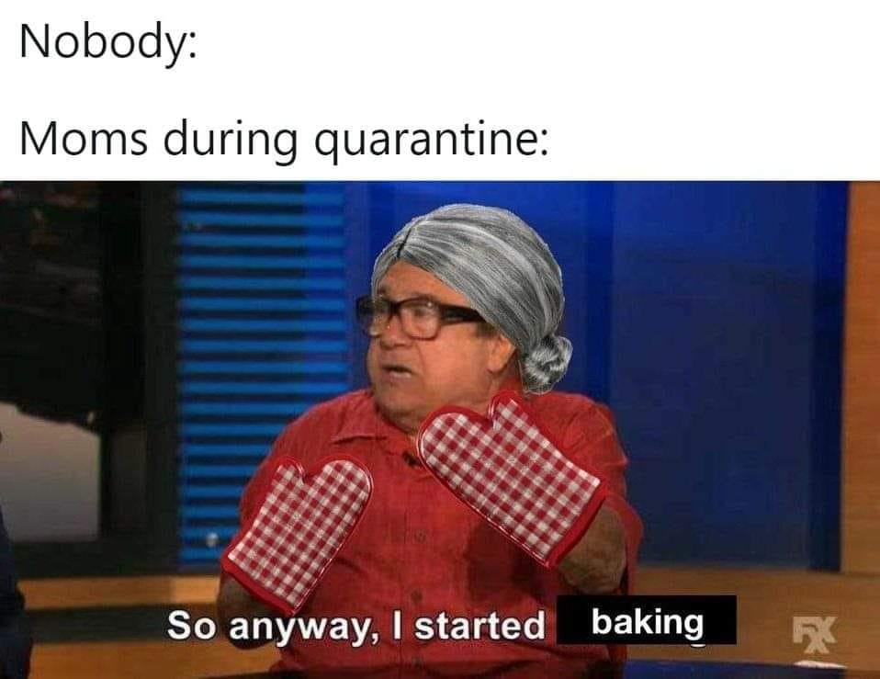
One thing I don’t mind about quarantine is the treats baked out of boredom.

This rearranged artwork reflects social distancing in a funny way.
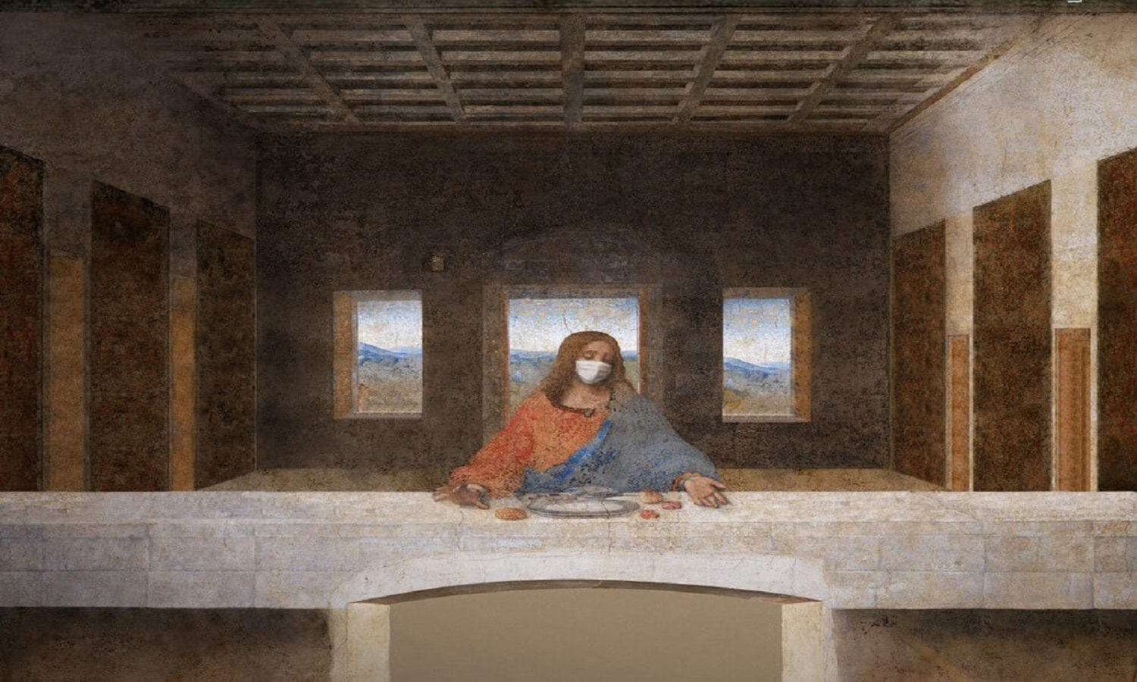
Some of the Books I’ve read so far during Quarantine.
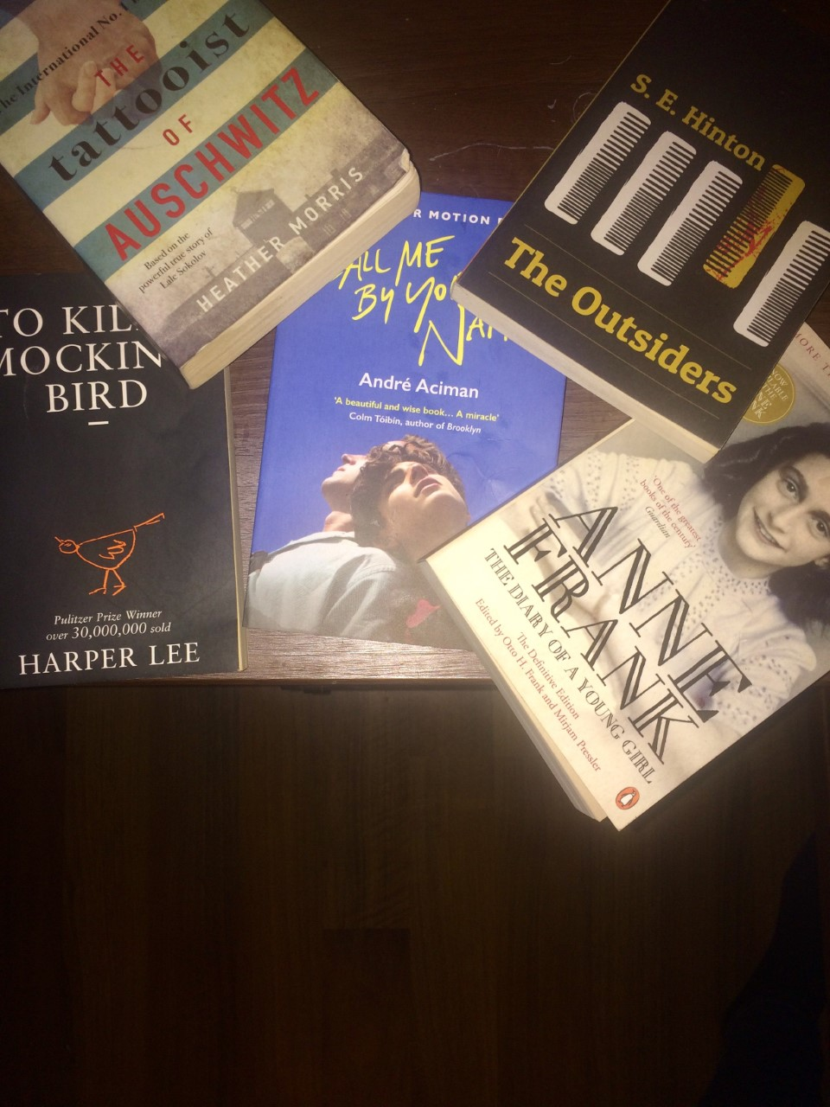

Some of the best Shows and The Movies I’ve watched during Quarantine:

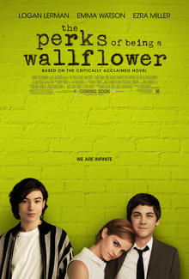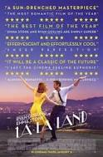

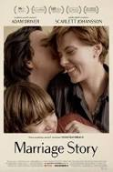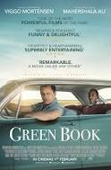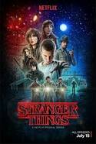

I’ve been reading quite a bit during quarantine, and so my mind has been to so many different settings! The below artwork speaks for me.
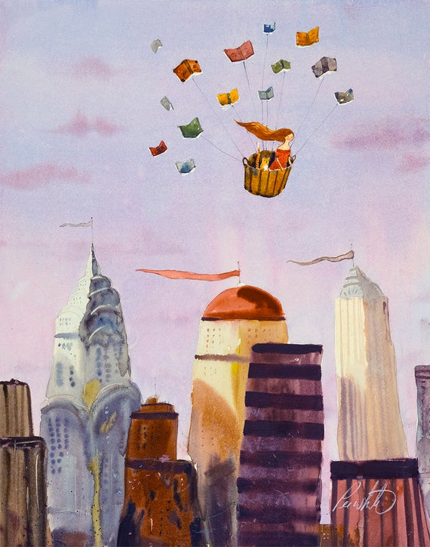

Gaming has always been a hobby, but everyone has been gaming more out of boredom and it’s a good way to talk to friends.

I’ve been cycling a lot during Quarantine, especially on Sunny days and I’ve really explored so much of the local area, I often find myself looking at similar views to the painting below.
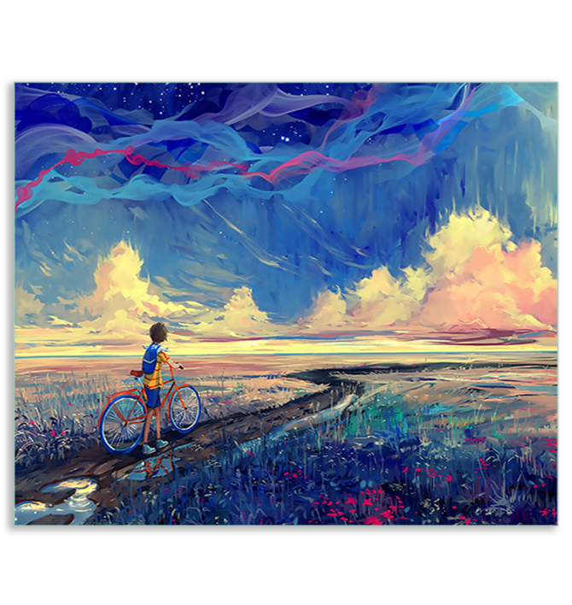
- Make a covid 19 Time Capsule.
In My Covid Time Capsule, I put:
My dog’s lead, on account of all the walks during quarantine.

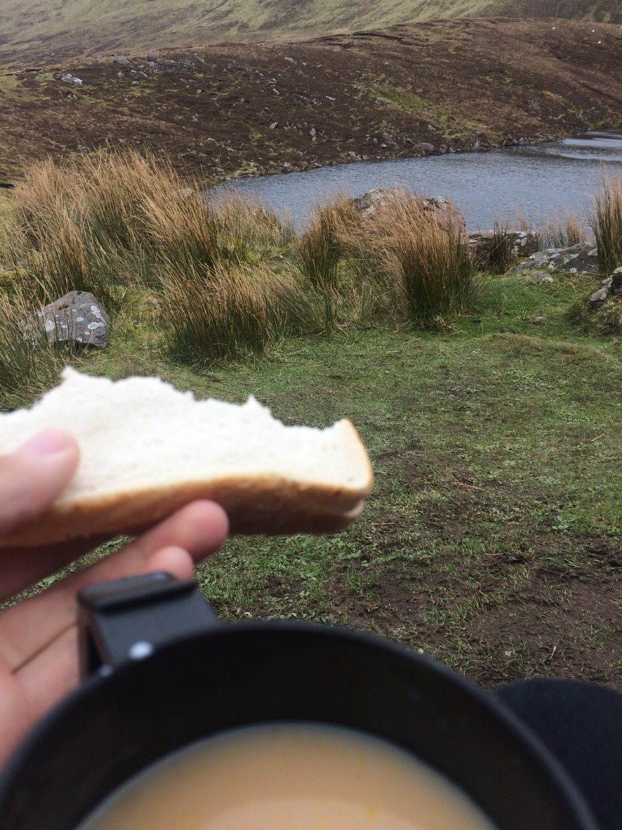
This flask which we carried tea in on the many hikes we did out of boredom.
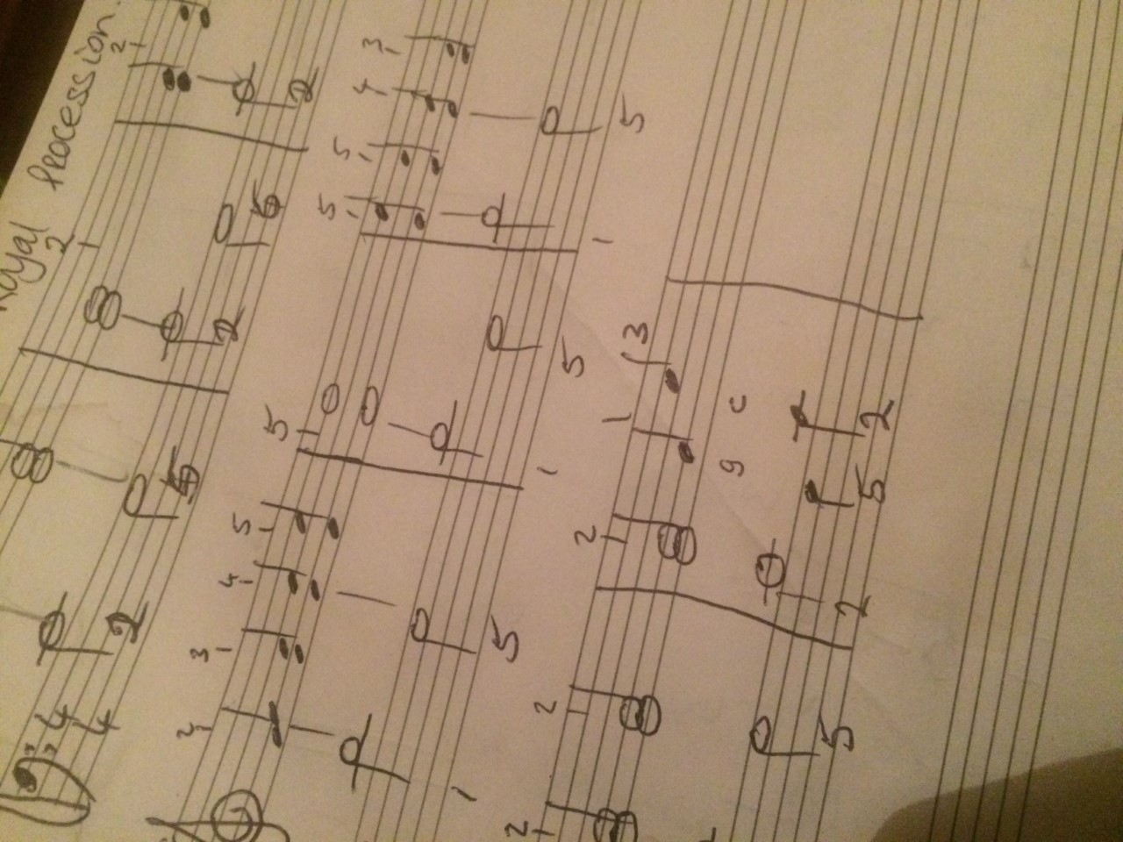
My Manucscript I used to compose and practice piano.

A face mask and some hand sanitizer.
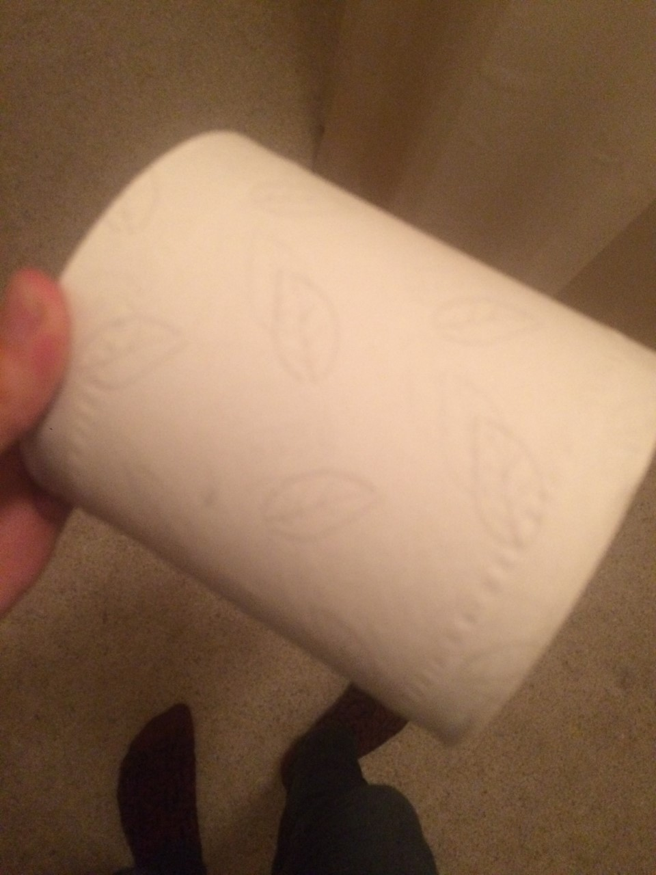
A roll of toilet paper to remember all the empty shelves in the toiletries section in stores
The books I’ve read in Quarantine.
I’ll put my headset and controller when I’m done with them due to the amount of time I played PS4 over Quarantine.
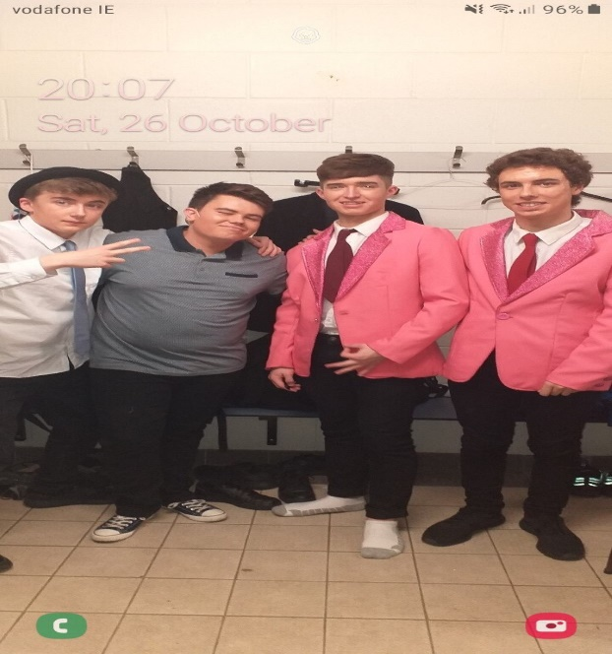

An old picture of me and the three people I talked to most in Quarantine.

- Get Outside!
- Every 2nd day I go cycling roughly around 12km and I walk my dog almost everyday. I do schoolwork outside in the good whether too as we have our outdoor furniture set up.
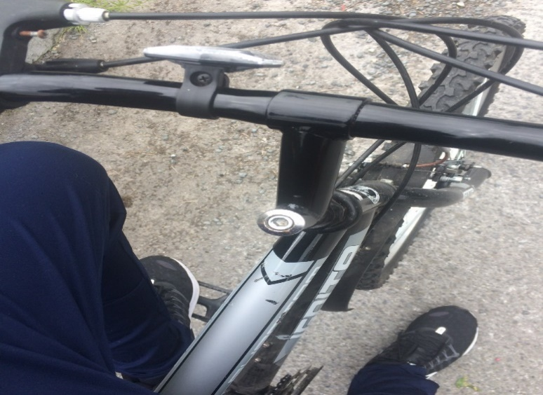
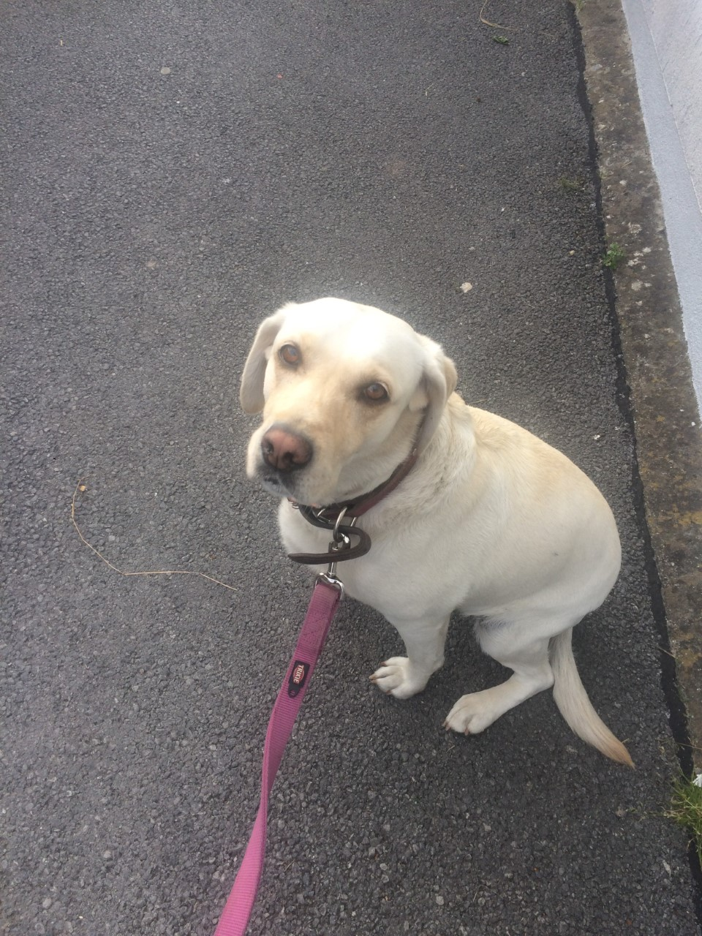

9. Teach yourself a new skill!
- Though it isn’t really a brand new skill, I have improved greatly on reading sheet music for piano.
- Before I was struggling to read notation and often had to number notes for my fingers.
- However after using apps such as musescore and online games after an assignment from Ms. Hall, our school music teacher, I am able to read notation far quicker and even compose a few pieces. This is not just a skill but a hobby now!

