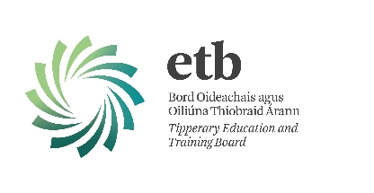
Tipperary Education and Training Board (TETB)

COVID-19 Return to Work Safely Protocol

In order to reduce the risk of the spread of COVID-19 in the workplace, TETB employees should follow all Public Health advice and guidance issued by the HSE and Gov.ie, as well as any specific direction from TETB.

Good hygiene practices must be adopted, such as frequent hand washing, respiratory etiquette and physical distancing, to protect themselves and their work colleagues against infection and should seek professional healthcare advice if feeling unwell.

If an employee has any symptoms of COVID-19, they should not attend work. Employees should also avoid making contact with their face and in particular their eyes, nose and mouth. Where necessary, employees should wash their hands immediately before touching their face.

Employees are advised to keep up to date with the latest measures introduced by the Government and any advice issued as a result.

Prior to returning to work in a TETB School/Centre/Office all employees must:
- Complete and return the Pre-Return to Work Form (below) at least 3 days before they return to work.
- Inform their Principal/Line Manager if there are any other circumstances relating to COVID-19, not included in the form, which may need to be disclosed to allow their safe return to work.
- Self-isolate at home and contact their GP promptly for further advice if they have any COVID-19 symptoms.
- Stay out of the workplace until all symptoms have cleared following self-isolation.
- Participate in any induction training provided by TETB on their return to the workplace.
- Complete any temperature testing as implemented by TETB and in line with Public Health Advice.

Tipperary Education and Training Board (TETB)

Pre-Return to Work Form

This form must be completed by all staff members and returned to their Principal or Line Manager before returning to work.
If you answer Yes to any of the questions below, you are strongly advised to seek medical advice before returning to the workplace and follow this medical advice:

Question |  | Yes or No
1. | Do you have symptoms of cough, fever, high temperature, sore throat, runny nose, breathlessness or flu like symptoms now or in the past 14 days?
2. | Have you been diagnosed with confirmed or suspected COVID-19 infection in the last 14 days?
3. | Are you a close contact of a person who is a confirmed or suspected case of COVID-19 in the past 14 days (i.e. less than 2m for more than 15 minutes accumulative in 1 day)?
4. | Have you been advised by a doctor to self-isolate at this time?
5. | Have you been advised by a doctor to cocoon at this time?

Proposed Date of Return to Work:
Employee Name:
Date:

Please return the completed form by email to your Principal/Line Manager at least 3 days before you return to the workplace.

