

*St. Ailbe’s School*

*Parent Information Booklet*





Principals Message

I am delighted to welcome both students and parents to the first part of our St Ailbe’s transition process.

We are fully aware that moving to a new school is a big change in the life for any young student, it is normal to have a few concerns or worries. I can say, with confidence that the St Ailbe’s transition process has worked very effectively over the last number of years with our current students. Each student will get an opportunity to see all parts of the school today during the treasure hunt and the other activities that have been arranged.

I would like to thank Alanna O’Donovan and the members of our School Completion Programme, Denis Keating, HSCL teacher, Ms Noreen Ryan and Ms Edel Merrigan, Guidance Counsellors, and all other members of staff who have contributed to the transition process. It is the continued dedication and hard work of all members of staff which makes St Ailbe’s the school that it is today.

Parents are always welcome in St Ailbe’s and I would encourage you to speak with either myself, our Deputy Principal, Mr Kieran O’Dwyer, or any member of staff if you have any concerns or worries.

In conclusion, I would like to thank you for choosing St Ailbe’s school and I look forward to getting to know all our new students and working with you over the coming years.

Regards

Ruaidhri Devitt

Principal

Contents

Handout 1: What your child needs to bring to school for each subject 4

Handout 2: Costs of Attending Post-Primary School 5

Handout 3: Timetable 6

Handout 4: Abbreviations on the Timetable 8

Handout 5:Teams 8

Handout 6: Structure of Post-Primary School 9

Handout 7: Junior Cycle Student Award Programme (JCSA) 11

Handout 8: Questions & Answers 13

Handout 9: TUSLA - The Child and Family Agency 16

Handout 10: Student Journal/Diary 18

Handout 11: VSware ……………………………………………………………………………………………………………………….19

# Handout 1: What your child needs to bring to school for each subject

General Items for Every Subject

**Pens at least 3 colours, Sharpener, Eraser, 2B & 6B Pencil, Ruler, Highlighters, Coloured Markers, Colouring Pencils, Packet of poly-pockets**

|  |  |
| --- | --- |
| Core Subjects | Materials |
| English  Irish  Maths  Science  History | 5 A4 hardback copy  4 120-page soft back copy  Casio Calculator  Mathematical Set  English Dictionary  Irish Dictionary  Project Maths Copy |
| Religion  SPHE (Social Personal and Health Education)  CSPE  Digital Media | 88 page soft back copy  88 page soft back copy |
| Optional Subjects |  |
| Geography  Business  Home Economics  Wood Technology  Graphics  French  Engineering  Applied Technology  Music  Art | A4 Refill Pad  88 page copy to be shared  No materials required |

Handout 2: Approximate Costs of Attending Post-Primary School

|  |  |
| --- | --- |
|  | € |
| Uniform  Available from O’Deas, Julies in Tipperary Town and Uniform World, Clonmel. | €50 - €80 |
| Shoes | €30 - €60 |
| St Ailbe’s Tracksuit  **Only Available from Idsportshop.com**  Half Zip, Track Bottoms, T-shirt  Soft Shell School Jacket **(Optional)** | €60 - €80 depending on size  €45 - €50 |
| Runners | €30 - €80 |
| Bag | €20 - €30 |
| St Ailbe’s Contribution/Fees | €150 |
| Lunch Money | €1.70 per day |
| Travel Costs | €3 per bus trip |
|  |  |
|  |  |

# Handout 3: Timetable

# Sample 1

# 

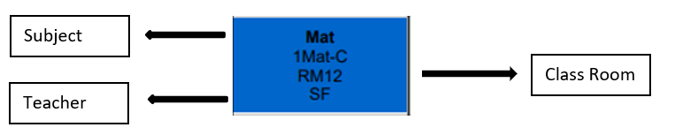

Sample 2: Timetable with Special Tuition (Special Tuition in White)

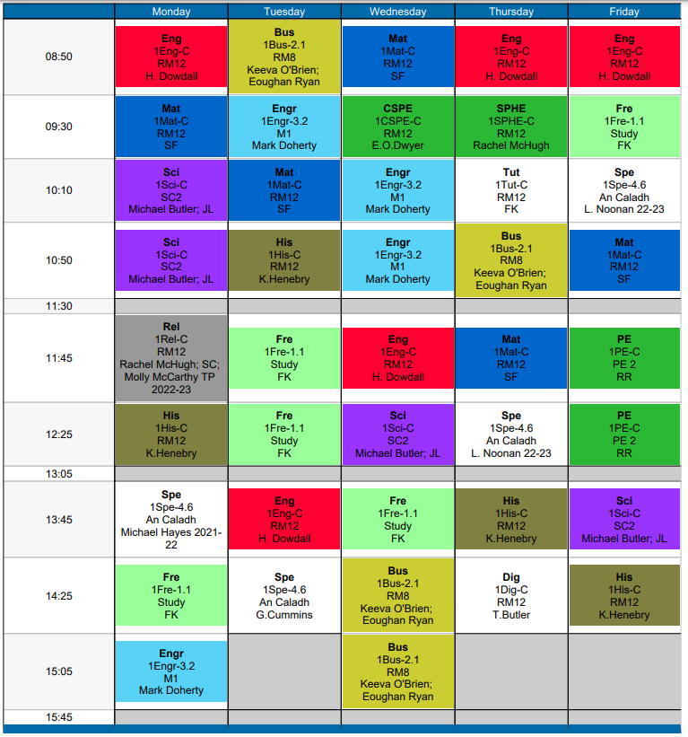



# Handout 4: Abbreviations on the Timetable

|  |  |
| --- | --- |
| **Abbreviation** | **Subject** |
| Iri | Irish |
| Mat | Maths |
| Eng | English |
| Fre | French |
| Sci | Science |
| Engr | Engineering |
| Wood Technology | Wood Technology |
| His | History |
| Geo | Geography |
| Bus | Business Studies |
| PE | Physical Education |
| Rel | Religion |
| SPHE | Social Personal and Health Education |
| Art | Art |
| CSPE | Civic, Social and Political Education |
| Dig | Digital Communications |
| Spe | Special Tuition |
| HmEC | Home Economic |
| Mus | Music |
| SpT | Special Tuition |
| Graphics | Graphics |

# Handout 5:

# Teams



# Handout 5: Teams

# Handout 6: Structure of Post-Primary School

|  |  |
| --- | --- |
| **JOB TITLE** | **NAME** |
| Principal:  (Head of the school) | Mr Ruaidhrí Devitt |
| Deputy Principal:  (Works closely with the Principal managing the school) | Mr Kieran O’Dwyer |
| 1st Year Head:  (In charge of looking after a particular year group) | Mr Denis Keating |
| Learning Support (SEN) Team  (Provides additional assistance to students) | Ms Mairead O’Connor  Ms Deirdre Clifford etc. |
| Guidance Counsellor:  (Supports Students’ Wellbeing) | Ms Noreen Ryan  Ms Edel Merrigan |
| Behavioural Support Teacher:  (Helps first year students to settle into the school and helps students with challenging behaviour) | Mr Michael Doyle |
| Home School Community Liaison Coordinator (HSCL):  (A link between the home and school.  Supports parents) | Denis Keating |
| School Completion Programme (SCP):  (Supports students) | Alanna O’Donovan |
| Parents Council:  (Represents the voice of the parents. Supports and promotes the school) | Chair: Mary Cummins |
| Caretakers:  (Takes care of the school building) | Nicky Cummins  Bob Martin |
| Educational Welfare Officer (EWO):  (Monitors school attendance) | Ita Teehan |

# Handout 7: Junior Cycle

All students entering 1st year will be examined in all subject under the JCSA criteria.

* A maximum of eight subjects.
* Short courses in new areas.
* New assessment arrangements.
* Focus on 8 Key Skills.

### Subjects:

**Core** (Everyone takes these): English; Irish; Maths; Science; History; Religion; CSPE; SPHE; PE

**Option**: (Will have to pick 1 from 3 bands) French; Geography; Art; Home Economics;

Music; Business; Wood Technology;

Engineering; Graphics; Applied Technology

Key Skills

Being Literate; Managing Information & Thinking; Being Numerate;

Managing Myself; Communicating; Being Creative;

Staying Well; Working with Others

Assessment – What’s new?

At the end of the 3-year cycle students will receive a Junior Cycle Profile of Achievement (JCPA) which will comprise of two Classroom-based Assessments, generally, one in 2nd year and one in 3rd year, the Assessment Task (10%) and a final assessment (90%) in 3rd year.

### Classroom-based Assessments (CBA)

CBA’s will happen during normal class time and can consist of Oral Presentation, Written Investigation, Experiments, Creative Textiles, Physical Activity Assessment, and Citizenship Action Record etc.

CBA Reporting

There are four descriptors of achievement for classroom-based assessment as follows:

▪ Exceptional

▪ Above expectations

▪ In line with expectations

▪ Yet to meet expectations

### Assessment Task (AT)

AT is a reflection carried out by the student on their learning experience after completion of the CBA, carried out during class and it accounts for 10% of the state certified grade they will receive.

### Final Examination

The final examinations will be:

▪ No longer than 2 hours

▪ English, Irish and Maths will have two levels, Higher and Ordinary

▪ All other subjects will be available at common level

### Final Examination Reporting

The following grades will be used:

▪ Distinction (90-100%)

▪ Higher Merit (75-89%)

▪ Merit (55-74%) 11

▪ Achieved (40-54%)

▪ Partially Achieved (20-39%)

▪ Not Graded (0-19)

In-House Exam Structure:

1st years sit in-house exams during October and Christmas on the core subjects only: Irish, English, Maths, French and Science

For Easter and Summer, they will be examined on all subjects using the grading/marking scheme outlined above.

# Handout 8: Questions & Answers

* What time does school start?

Every morning at 8:50 am

* What time does school finish?

Monday and Wednesday at 3:45pm

Tuesday, Thursday and Friday at 3:15pm

* What times are break and lunch times?

Break: Monday and Wednesday at 11:30 to 11:45 (15 minutes)

Tuesday, Thursday, Friday at 11:30 to 11:55 (25 minutes)

Lunch: Monday and Wednesday at 1:05 to 1:45 (40 minutes)

Tuesday, Thursday and Friday at 1:15cto 1:55 (40 minutes)

* Is there a Breakfast Club?

Yes, Free for everyone and runs from 8:15 – 8:45 am every morning

* Is there a Homework Club?

Yes, 4 evenings a week, **places are by application only.** Application email will be sent out during the first week of school.

* Is there evening study?

Yes, evening study is available **for 1st years Monday to Thursday for 1 hour** and it is free of charge. There will be food available for students doing evening study; this is also free of charge.

* Are there extracurricular and lunch time activities?

All these activities are FREE and include the following:

Basketball, Rugby, Football, Hurling, Coding, Camogie, Soccer, School Musical, Spike ball

* Is there a book scheme?

Yes, the books, insurance and locker are included in the school fee.

* Where can I buy the uniform?

Uniform is available from the O’Deas, Julies and Uniform World.

* How long are First Year Students recommended to spend on homework?

We would recommend 11/2 hours between homework, going over what was covered in class during the day and study.

* What do I do if my child is absent from school?

Parents can log onto their VSware account and submit an absence request. If there is any issue with VSware parents can send a note in the student diary or call the school.

* What subjects are on offer?

Core: Irish English, Maths, Science, History, Religion, SPHE, CSPE and PE

Optional: Art, Music, Graphics, Wood Technology, Home Economics, French, Business, Geography, Engineering, Applied Technology.

Students will pick a subject from Block 1 (French, Art, Applied Technology, Wood Technology, Geography) before starting 1st year, either through an on-line survey or based on discussions at the one-to-one meetings with Mr Devitt or Mr O’Dwyer. The remainder of the subjects are given on a 3-week block of tasters and you will have to pick 1 from the 2 Options Bands which will be formed after Mr Devitt surveys the students in relation to choice.

* How are subjects grouped? Can I do Home Economics and History?

Students need to pick from option block one (French, Tech, Art, Wood, Geography) before they start. The reason for this is that we don’t want to wait 15 weeks before starting French. Students will do tasters of all other option subjects prior to picking you subjects from option blocks 2 and 3 at Christmas.

* What happens if my child has an exemption from Irish?

**A certificate of exemption from their primary school must be made available to St Ailbe’s** before an exemption can be availed of.

* How are the lockers organised?

The lockers will be assigned to the students on registration day after the contribution is paid. All 1st year lockers are located in the canteen area, locks are provided and spare key must be given to the caretaker.

* How can I help my child succeed in secondary school?

**Look at their VsWare and journal every day or at least once a week**, **Journal must be signed every week;**

keep in contact with the school either by VsWare, telephone or by using the journal;

know what subject they are choosing and why;

know their teachers and year head;

**check to ensure they are doing homework**;

check that they have all the necessary books and class materials for every subject;

try to have a bank of spare A4 hardback and softback copies, pencils, biros etc., this will prevent them from making excuses not to complete class work and homework;

make sure they are in proper uniform every day;

attend all Parent/Teacher meetings;

Ensure they have a good attendance at school, for example avoid family holidays during the school year.

* Is there HSCL (Home School Community Liaison)?

Yes, the Home School Community Liaison is the parent/teacher link between the home and school and their role is to support the parent/guardian to enhance pupils' learning opportunities and to promote their retention in the education system.

* Is there a Learning Support coordinator/department?

Yes, there is a Learning Support Team which consists of a number of qualified teachers. Based on initial assessments and on-going assessments students may be offered Learning Support. Access to Learning Support will be subject to periodic review.

* Will I have access to my child’s assessment results?

**Yes, results will be available on VSware**, results are no longer posted.

1st years are assessed 4 times a year, October, Christmas, Easter and Summer. Results of all assessments will be available on VSware.

* Who is my first point of contact if I need to discuss an issue about my child? How do I go

about it?

Mr O’ Dwyer, Mr Devitt and Mr Keating are your first point of contact, or any staff member you feel comfortable with. You can ring the school to make an appointment, or if it is urgent come in and they will make time to see you.

* How are First Year classes divided? Streaming or Mixed ability?

Classes are divided into mixed ability, we provided Team Teaching for students who need extra support in Maths and English based on their CAT test results.

* Does the school have a policy on bullying?

Yes, we have a policy on bullying and it is taken very seriously in St Ailbe’s. Any incidents of bullying should be reported immediately to Principal or Deputy Principal where they are dealt with immediately and in an appropriate manner. The policy and all other policies are available on the school website, under ‘Downloads’.

* Are 1st years allowed down town at lunch-time?

No students from the Junior School are allowed down town at lunch time.

* What happens if I drop my child early for school?

The school is open from 8am on wards and there is a member of staff on supervision from 8:30am. If dropping your child early you should inform them that it is in their best interest to stay on the school grounds until school starts.

* What is SCP?

It is the School Completion Programme, it provides in school and after school supports for children to help them attend and participate in the educational and social part of school

# Handout 9: TUSLA - The Child and Family Agency

PARENTS’ LEGAL RESPONSIBILITIES WITH REGARD TO THEIR CHILD’S EDUCATION

* Every child aged between 6 and 16 must receive an education.
* Your child has a right to an education.
* A good education, combined with loving care and encouragement, will

give your child a great start in life.

* A good education means your child will be more likely to: Learn more,

Develop their skills and talents, Make and keep friends, Have more

confidence, do better at exams, be happy in life, be employed, Get a higher

earning job when they start working and avoid getting involved in crime

WHAT YOU MUST DO IF YOUR CHILD CANNOT BE AT SCHOOL:

* You must tell the school that your child cannot attend and say why.
* The school will tell you how to give them this information – **usually, the school will ask for a note.**
* Very often, there will be good reasons for a child not being in school and these will be taken into account if they are explained to the school.

WHAT THE SCHOOL MUST DO IF YOUR

CHILD MISSES A LOT OF SCHOOL:

* The school must tell TUSLA if your child has missed 20 days or more in the school year or if it is concerned that your child is missing too much school.
* If your child misses a lot of days due to illness, you must send in doctor’s notes to cover these days.

WHAT CAN I DO IF THE SCHOOL IS PREVENTING MY CHILD FROM ATTENDING?

* If a school has refused to enrol or has suspended or expelled your child and you are not happy with that decision, you can appeal it.
* You can do this by filling in an Appeals Form which should be available on request from the school (or ETB) or can be downloaded from the Department of Education and Skills web-site at education.ie

CAN I TAKE MY CHILD ON HOLIDAYS DURING TERM TIME?

* Taking a holiday during term time means that children miss important school time, both educationally and for other school activities.
* It will be difficult for them to catch up on work later on.
* As a result they may fall behind with school work and lose confidence in their abilities.
* Every day counts in a child’s education and parents are strongly advised against taking their children
* out of school for holidays during term time for this reason.

TOP TIPS FROM PARENTS:

* Get your child to bed in good time on school days and Sunday nights. Plenty of sleep and rest will help a child stay alert.
* Set the alarm clock in good time and get your child to school on time.
* Help your child pack his or her schoolbag the night before.
* Prepare your child’s lunch the night before so you and your child have more time to get ready in the morning.
* Keep school clothes and books neat and ready for use.

PROTECTING YOUR CHILD’S RIGHT TO EDUCATION:

* TUSLA will help you in whatever way they can to ensure your child gets an education.
* However, you can be taken to court and fined or imprisoned if you do not co-operate with the Board.
* Legal action will be taken in exceptional cases if it is the only way a child’s right to an education can be safeguarded.

HOW CAN I HELP MY CHILD TO ATTEND SCHOOL?

* Make education important in your home and let your child know it is not okay to miss school.
* Show that you think education is important. Look at your child’s school books. Ask about what they are doing. Be interested in their news.
* Help your child to be proud of a good attendance record.
* Build your child’s confidence. Praise them when they do well.
* Read letters and reports from the school and know the school rules.
* Go to school meetings and get to know the teacher, staff and your child’s friends.
* Don’t take family holidays during school term.
* Be alert for reasons why your child may not want to go to school. If your child finds school work hard, talk to the school right away.
* Do not encourage your child to take on a part-time job during school term.

## WHAT SHOULD YOU DO IF YOU NEED SUPPORT?

You can contact an Educational Welfare Officer on low-call number 01 771 8500

Check out the website on www.tusla.

# Handout 10: Student Journal/Diary

# Important points in the Journal

|  |  |  |
| --- | --- | --- |
| **Page No** | **Information** | **Reasons** |
| 1 | Class Timetable | Complete with your child when the receive their timetable |
| 2 | Student/Parent Details | Necessary for Class Teacher/Others in case of emergency or if internet is not available. |
|  |  |  |
| **5 to 16** | **Code of Behaviour** |  |
| 5 | ‘the right to education of the overwhelming majority of pupils must not be subverted by a disruptive minority’ |  |
| 6 | 2. .. ‘to facilitate Parent’s checking the student journal it is essential that students bring home the student journal each evening.’  4. ‘Loss …reported immediately to the Year Head…. replacement fee of €10 | The school’s way of keeping the Parents informed of what is happening on a daily basis during class time; teachers note on student progress, check every night and sign at the end of the week, page 34. |
|  |  |  |
| **7** | **Role of Parents/Guardians** |  |
|  | 4. ‘Provide all the necessary information to St Ailbe’s.’ | It is essential to keep the school informed on student medical and other needs throughout the year as the home has a huge impact on how a child develops at school. |
|  |  |  |
| **8** | **Punctuality and Absenteeism** |  |
|  | 2. ‘**Students who are late for school in the morning or the afternoon must report to the main office an arrival’ and a late note will be issued** | **Each teacher takes the roll for 1st class and late students will be marked absent, if they do not report to the office they will be marked absent and a text will be sent home to this effect.** |
|  | 4. ‘**Where a student is absent from school …. Parents/Guardians shall inform the school for the reason for the child’s absence’.** | Parents must ring the office and note will be made, unexplained absents in excess of 20 days will result in a report being made to the Education Welfare Board. |
|  | 6. ‘School management cannot accept responsibility for students who absent themselves from school without permission’. |  |
|  |  |  |
| **9** | **Procedures for leaving school during school day** |  |
|  | **1. ‘In order to obtain permission to leave school, Parents/Guardians must complete and sign the permission form in the journal’, page 28.** | Must be presented at the office before student is allowed to leave and sign out.  School has to account for students at all times. |
|  | 4. ‘1st, 2nd & 3rd students must remain within the school during lunchtime’. |  |
|  |  |  |
| **10** | **School Uniform and Appearance** |  |
|  | Full uniform must be worn at all times, white shirt, navy jumper with school crest, navy blue pants, pleated check skirt, navy tight or knee length socks, plain shoes.  Any shoe/runner with visible logo’s coloured strips, coloured laces etc. are not allowed. |  |
|  |  |  |
| **11** | **Mobile Phones/Electronic Devices/Internet Usage** |  |
|  | 1. ‘The office phone is available to students for contact with Parents/Guardians’. |  |
|  | 2. ‘Mobile phones ….should be powered off and out of sight during the school day’. | Students cannot concentrate if using the phone during class and it is extremely disrespectful to teachers and fellow students. |
|  | Student will be requested to turn off and hand over the device to staff member.  Device can be collected by parent/guardian at the end of the school day. |  |
|  | 3. ‘The school reserves the right to retain the device and/or storage media and hold it for further examination by the relevant authorities’. |  |
|  | 5. ‘St Ailbe’s cannot be held accountable if any such item goes missing’. |  |
|  |  |  |
| **12-16** | **General Points** |  |
|  | Smoking/Vaping is not allowed on school grounds.  Chewing gum in not allowed.  Correction fluid is not allowed.  Inappropriate language is unacceptable at all times.  Students must be punctual for all classes and have all the proper materials.  Students may only leave the classroom with the teachers’ permission and their journal must be signed by the teacher.  Rudeness, insolence, aggressive behaviour to member of staff will not be tolerated and my result in immediate suspension and or expulsion.  If a student’s behaviour becomes unsatisfactory sanctions may be imposed. |  |
|  |  |  |

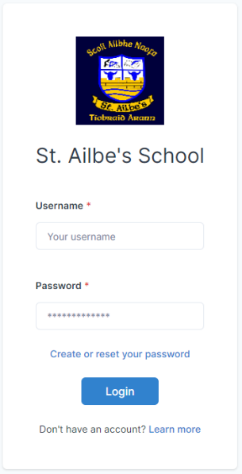Handout 11 – Vsware

We highly recommend that parents/guardians check VSware on a regular basis, at least once a week. You can access VSware using the link ailbes.vsware.ie or by downloading the VSware app onto your phone. A username will be sent to you at the start of the year.

As well as checking your child's progress in term assessments, you can also view punctuality, behaviour, submit an absence request and much more.

For a general guide to VSware for parents follow the following link:

<https://support.vsware.ie/en/parent-app-overview>

Here is a video on VSware's uses for parents:

<https://vsware.wistia.com/medias/tmb3s409kt>

To find out how to view term reports follow the following link:

<https://support.vsware.ie/en/parent-app-assessment-notes>

This link is a video on how to submit an absence request:

<https://support.vsware.ie/en/a-parent-sending-an-absence-request>

Before Christmas, 1st year parents will be asked to enter the subject options for their child. Here is a video on how to do this:

<https://vsware.wistia.com/medias/n7yo7lck0k>

If you would like someone to go through VSware and its uses with you, please let me know at denis@ailbes.com or 062-51905 Extension 103 and we can arrange an appointment.