At St. Ailbe’s in 2023/2024, we aim to introduce the use of restorative circles in our classroom and for teachers to use restorative questions when solving conflict.
What is restorative practice?
Restorative practice is based primarily on a set of core values and the explicit promotion and enhancement of particular skills such as the ability to empathise and to find solutions to specific problems. This practice allows for building trust between and with people. It provides a structured approach in the form of a scaffold, which helps build and sustain relationships, and provides a focus which allows for the potential growth of positive relationships to become established between people. The development of each relationship is based on a set of core values. These values include respect, and being respectful of everyone, including towards people someone maybe doesn’t always see eye to eye with or even like.
Through the development of empathy, and promoting understanding of perspective taking, people can learn to respect each other and where someone is coming from in terms of their own expression of thought and feelings. In our efforts to show empathy, as human beings we are able to harness the notion of fairness into our relationships, and therefore can also account for our own actions and hold others to account for theirs.

Restorative [Practice programmes] in schools aim to develop:
• communities that value the building of quality relationships coupled with clear expectations and limits
• restorative skills in the way we interact with young people – using teachable moments to enhance learning
• restorative processes that resolve conflict and repair damaged relationships
• communities that are forward looking, optimistic, and inclusive.
(Harrison, 2007, pg. 17)

Please click on the link below to watch a restorative circles:
Restorative Problem Solving Circle in School
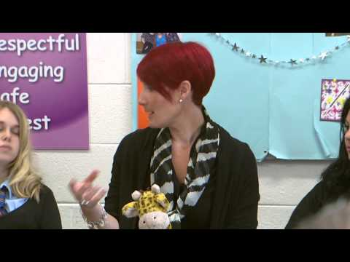

Please click on the link below to understand how the restorative practice questions are used:
Restorative Approach Example - Primary School
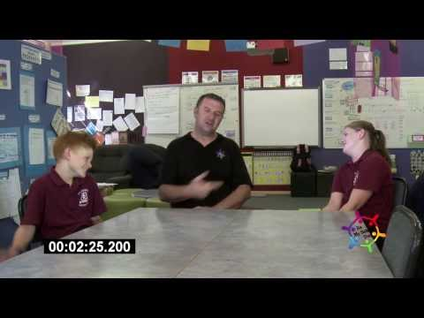
Restorative Practice Questions:
What happened?
What were you thinking of at the time?
What have you thought about it since?
Who has been affected and in what way?
How could things have been done differently?
What do you think needs to happen next?

