

**St. Ailbe’s School**



**HOMEWORK POLICY**

|  |  |
| --- | --- |
| **Policy Area** | Schools |
| **Policy Reference number** | ST.AIL/HOME/019/0 |
| **Version** | 1 |
| **Document created by** | St. Ailbe’s School |
| **Date previous version:**  **Ratified by SLT**  **Noted by TETB** | N/A |
| **Date Reviewed / Amended by School** | May 2023 |
| **Date Reviewed / Ratified by Senior Leadership Team – CE & Directors** | 19 June 2023 |
| **Date Noted / to be Noted by Tipperary ETB Committee** | 5 September 2023 |
| **Policy Review Date** | Every two years |
| **Date of Withdrawal of Obsolete Document** | N/A  Document Ref. No. –  Version No. - |

**Striving for Personal Excellence**

*“The intrinsic value of homework activities is far more important than the precise amount of time devoted to them”.*

***Looking at Our Schools***

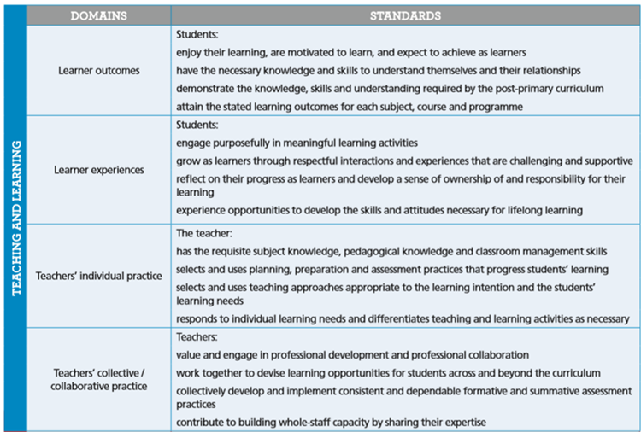

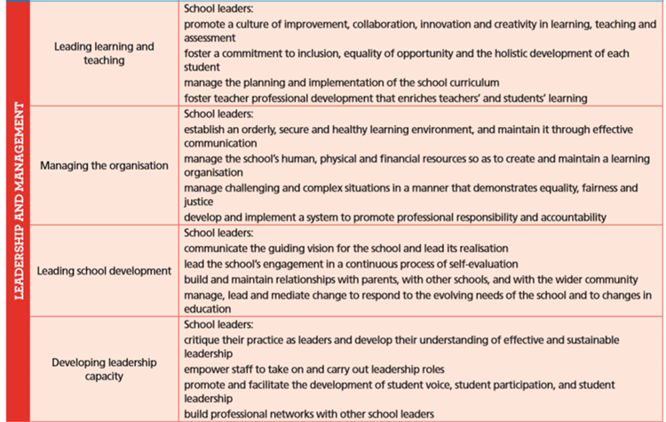

**The purpose of homework**

• It consolidates and reinforces skills and understanding developed at school.

*•* It encourages students to develop the skills, confidence, self-discipline and motivation needed to study effectively on their own.

• It extends school learning, for example through additional reading.

• It sustains the involvement of parents in the management of students’ learning and keeping them informed about the work students are doing.

• It directs research.

From the beginning of First Year each student is expected to establish a homework routine. Each student is expected to keep a record of all homework in their Journal, which is given by the school to the students specifically for this purpose. Journals are regularly monitored by the class tutor/year heads and are available to all teachers should they wish to communicate with parents. All homework should be completed and organised as guided by the subject teacher and should be dated. This assists with revision. A class teacher to communicate initially through the journal or VSware if a student fails to present written assignments or has failed repeatedly to complete learning assignments.

Teachers and parents need to consider the varying abilities of students when setting homework or when inspecting homework.

The school expects that all homework is completed on time and presented on time. It should be done to the best of the student’s ability in a neat and tidy fashion. It is very important that homework, including sanctions for not completing it (Code of Behaviour), should be consistently applied across the school so that all pupils see the arrangements as fair**. If a student has been absent the onus is on the student** **to discover what work has been set and to endeavour to complete it within the** **time given in as far as is possible**. If the student has been ill, a period of time will be given to the student to complete missed assignments.

It is also necessary for both teacher and parent to ensure that there is a healthy balance between time allocated to homework and time allocated to extracurricular and leisure activities. (Link to EC policy and the guidelines set out here [School Policies – St Ailbe's School (stailbes.ie)](https://www.stailbes.ie/downloads/school-policies/).

**The role of parents/guardians in supporting pupils**

* Parents/guardians are encouraged, as far as possible, to provide a reasonably quiet, suitable place in which students can do their homework free of distractions such as television, mobile phones, laptop. etc.
* Provide suitable desk, chair, adequate light and heat.
* A regular time should be set aside for homework.
* Junior Students may attend Homework Club.
* Senior students may attend after-school study.
* It is the parents’/guardians’ responsibility to inform the school or class teacher of any reasons why a student was unable to complete a homework assignment.
* A parent/guardian may communicate this through the student’s journal or VSware.
* If a parent/guardian feels that her daughter is struggling with the amount of homework or degree of difficulty of some he/she may communicate this to the class teacher.
* Parents/Guardians are expected to check VSware and sign the Journal weekly.
* Individual notes from school personnel should also be acknowledged.
* Parents/Guardians may communicate with a class teacher at parent/teacher meetings regarding homework.
* Since computers are an integral part of today’s world, it is inevitable and essential that the Internet is a source for much of their research.
* Parents/Guardians are encouraged to monitor their child’s use of the Internet.

**Study skills**

It is very important that students should have frequent and increasing opportunities to develop and consolidate their competence as independent learners. These can be achieved through study skills and target setting. Each individual class teacher provides tips on the specific requirements within his/her own specialist subject area. Meeting homework deadlines may not be always easy for students. They should not be excused homework, but may need extra help with strategies to manage it.

**Appropriate tasks for homework**

The range of tasks which are appropriate for students of various ages are many and varied. Some examples are as follows:

* Written assignments
* Learning assignments
* Essay writing
* Reading Investigations
* Interviews
* Drill practice
* Simple experiments
* Research
* Public Library visit
* Drafting
* Report Writing
* Designing
* Revision Work Practice of some procedure
* Problem solving
* Preparing for debates, role-plays etc
* Preparing for class tests or exams
* Making a model Drawing
* Word processing Projects
* Watching a television documentary
* Listening comprehension

Tasks should have a clear objective, linked to study programmes. They should be both challenging and interesting. Teachers are encouraged to check that their overall homework programme is meaningful and balanced in the type and scale of tasks and manageable for students. This balance is not always possible and can vary considerably from day to day. However, it should be noted that homework time devoted to reading and learning is as important as written work. All students should spend time at home on their studies whether or not work has been assigned. If no homework has been set then students have an obligation to go over material they have recently studied in class to make sure that they have fully understood it.

**Special educational needs**

In setting homework for students with special needs, teachers are encouraged to balance the right of students to share fully in the work of the class, including homework tasks, with their individual learning needs. These needs may include consolidation and reinforcement of specific skills. For some students, the continuing involvement of parents is very valuable. Subject teachers will collaborate where possible with Learning Support teacher to ensure class tasks are manageable, and individual skill practice can be incorporated without overloading the students.

**Feedback for pupils**

Students look mainly to teachers for a response on the quality of their work. Effective marking and feedback have always placed demands on teachers, but both are fundamental to helping students make progress. Teachers check homework on a regular basis. A variety of methods are used to correct homework:

* Teacher correction
* Class correction
* Class discussion
* Students exchange work for correction
* Students write out answers in the form of a test
* Some items of homework (and class work) may be checked by students themselves under the direction of a teacher. This can be a useful part of the learning process for students.

The school reports to parents/guardians on the progress of students and indeed reporting is a crucial part of the relationship between school and parents. Traditional school end of-term reports that take the form of a grade/mark and a comment for each subject can be reassuring and supportive for the parents of students. Parent/teacher meetings offer valuable opportunities for the school to move beyond the marks, as it were, and to present more comprehensive assessments of progress. As well as allowing a focus on progress achieved, such meetings provide an opportunity to nominate areas that need specific attention and to indicate what needs to be done to improve student performance.

**Arrangements for monitoring and evaluating homework policy**

The effectiveness of this homework policy needs to be monitored and evaluated. It is envisaged that each subject department monitors homework within the department at subject department meetings. Teachers need to evaluate the quality of homework and the contribution it is making to learning. The system can also be evaluated through staff appraisal at staff meetings and through the school policy review team. In addition to monitoring arrangements the homework policy needs to be reviewed regularly to assess its effectiveness. The key criterion should be the extent to which the policy is contributing to the progress students make at school and their attitude to learning.